Elbert Glen McGuire
Born: July 25, 1910 –Senath, Dunklin, Missouri, United States
Married: December 22, 1928, Osceola, Mississippi, Arkansas, United States to Ada Morgan
Death: 5 Oct 1982, Renton, King, Washington, United States – Prostate Cancer
When I think of my Grandpa, Elbert Glen McGuire, this is how I remember him. He always seemed to have a smile on his face, or looked like he was going to break out into a smile at any moment. I know he had hard times, but he was a good man and I think he did the best he could in this life, with his upbringing, his lack of education, and he tried to provide for his family. I always felt loved when I was with him.
He was 5’11, according to his WWII draft Card, his eyes were Brown, and his hair was Brown (I only remember it as grey). He didn’t seem that tall to me.
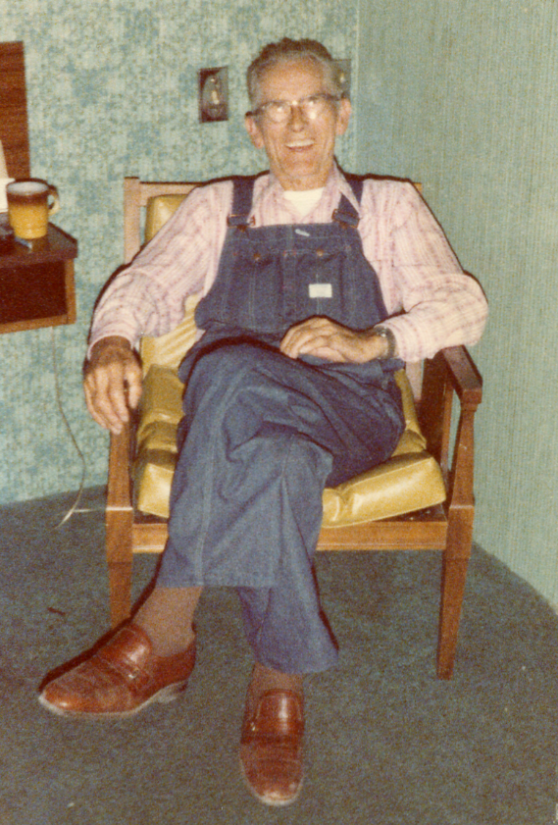
Grandpa McGuire was the 5th of 7 children born to John Thomas McGuire and Elizabeth Maud Howard, the last of their children to be born in Dunklin County Missouri before they moved to Manila, Mississippi County Arkansas by 1915.
Elbert’s Father, John Thomas McGuire was born in 1874 and was orphaned at age 3. John had a difficult life, leaving the Taylor home as a child, and I cannot find him on a census record until 1910. John Thomas was an alcoholic, a trait that unfortunately, afflicted some of his descendants, including his son, Elbert. Elbert overcame this addiction prior to his retirement.
On the 1910 Salem Township, Dunklin, MO Census is where he would be born 2 months later. His mother is listed as having had 4 children with 3 living. George died in 1909
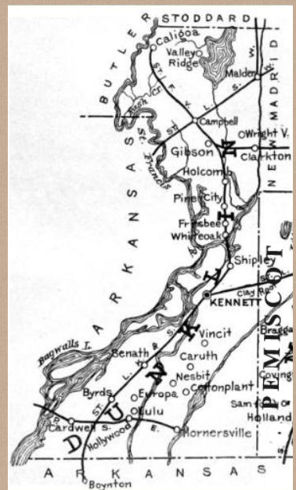
According to his daughter, Virginia Louise McGuire Rogers, Grandpa attended Marked Tree School. I found a Marked Tree in Dunklin, but failed to jot it down.
On the 1920 Big Lake, Mississippi County, Arkansas census their family consists of
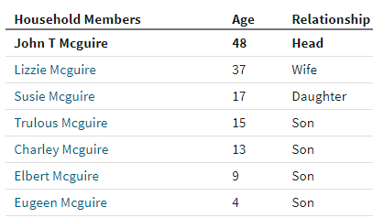
By 1930 his parents were living in Little River, Mississippi, Arkansas and Elbert and Ada (nee Morgan) and their daughter Virginia was living next door. Mom really shouldn’t have been listed on the census, it was supposed to be as of April, but I am not complaining.
Elbert McGuire and Ada Morgan were married on December 22, 1928 in Osceola, Mississippi, Arkansas. The picture on the left is a known wedding day picture.
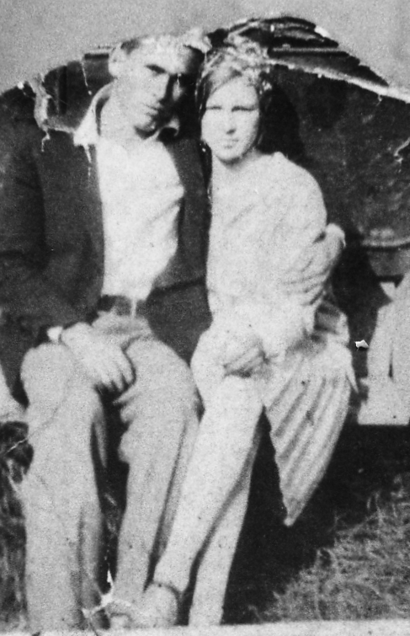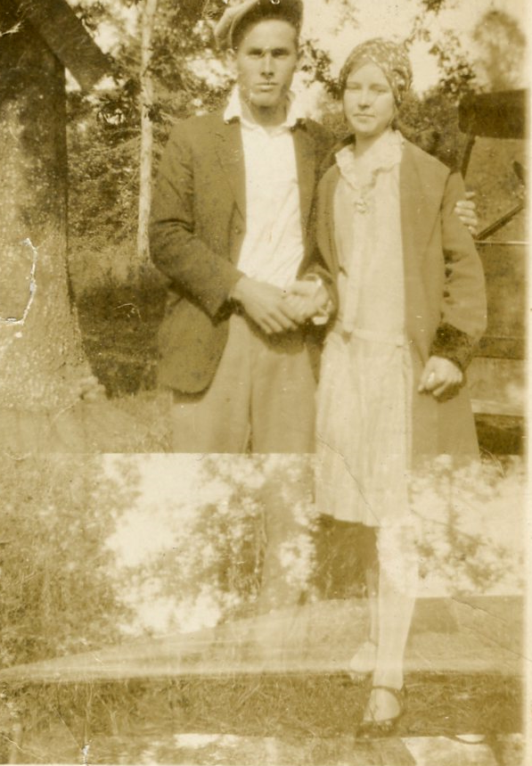

Elizabeth Maud Howard McGuire, Lizzie or Granny, did not want any of her sons to marry. She refused to attend the marriage of Elbert and Ada on December 22, 1928 in Mississippi County Arkansas. It is not known why, but she went as far as to tell Eugene he had syphilis to keep him from marrying. Elbert and John T. were the only 2 sons to marry during Lizzie’s life. Charles McGuire married in 1967 to Jimmie Ozella Fuller.
On the 1940 Corcoran Judicial, Kings County, California Census, Elbert lists his highest education grade as 5th. His Daughter, Virginia, always said it was 7th grade.
Grandpa registered for WWII on October 16, 1940 in Corcoran California. I know he did not service in the War. Mom always said he was classified III-A deferred for dependency reasons.
Also on the 1940 census he lists he is a laborer with the W.P.A. Road Project (Works Project Administration). In researching this project it states that the project was an American New Deal Agency, employing millions of job-seekers (mostly unskilled men) to carry out public works projects. Works Progress Administration - Wikipedia

The article also states: These ordinary men and women proved to be extraordinary beyond all expectation. They were golden threads woven in the national fabric. In this, they shamed the political philosophy that discounted their value and rewarded the one that placed its faith in them, thus fulfilling the founding vision of a government by and for its people. All its people.
— Nick Taylor, American-Made: The Enduring Legacy of the WPA^{[21]:530}

I was not surprised to read this as Grandpa was good with his hands. He built at least 3 homes for his family. This one was in Arkansas, and my Mom, Virginia McGuire Rogers, and Uncle Lucky were born here.

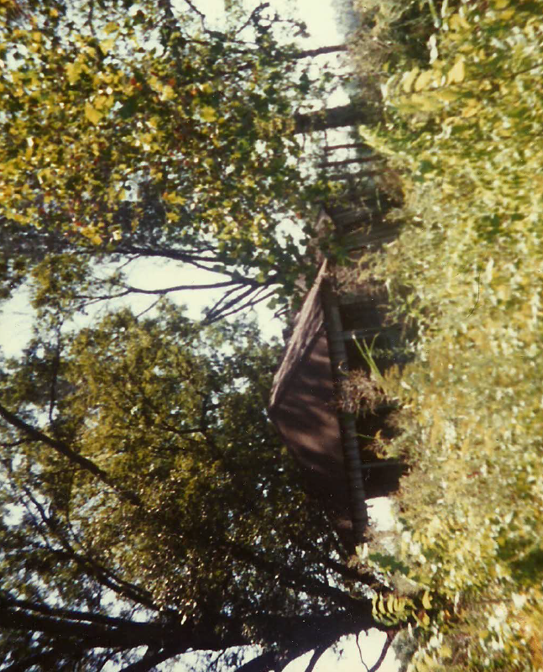

This one was in 1942/1943 in California.
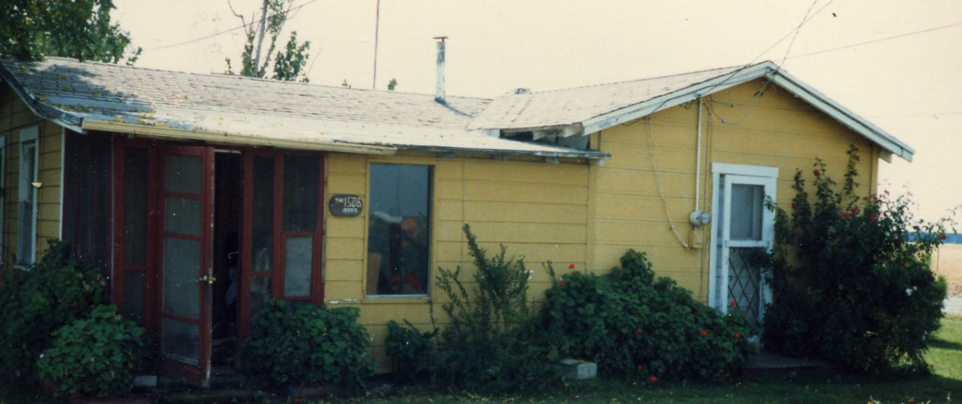
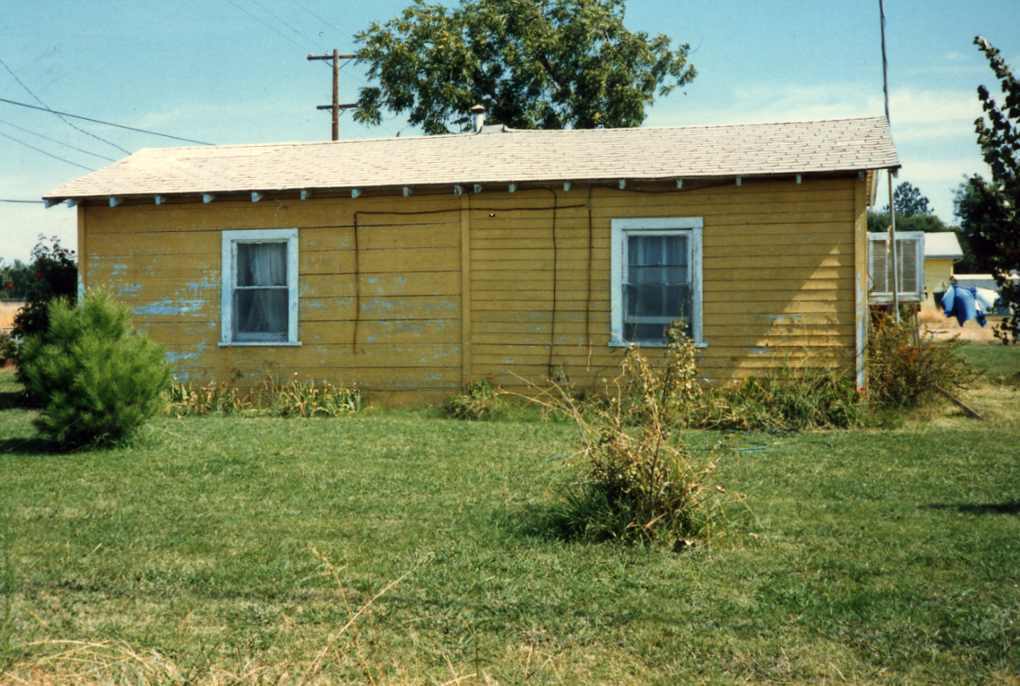

And his last home at 30031 164th Ave SE, Kent Washington , where many family gatherings were held. (looking for a good picture of this home) this picture below was taken at Grandpa’s retirement party.

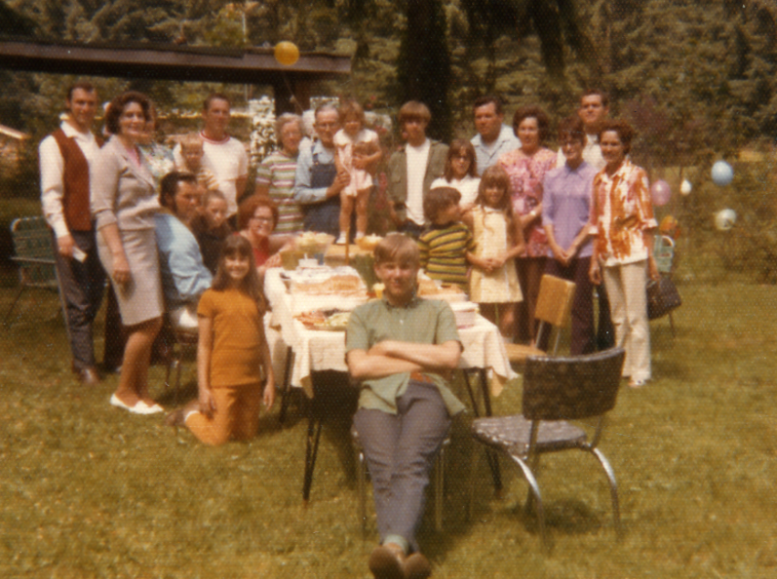

In August of 1955, Terrell and Virginia Rogers, who were living in Renton Washington at the time, went on vacation to California to see both their parents. When they arrived at the McGuire home, everything was packed up and they were heading to Washington. So much for vacation, the family all returned to Washington.
Grandpa was employed by Pacific Car and Foundry Company, where he was called Mac. He retired in 1972 and their children presented them this traveling camper, see below.
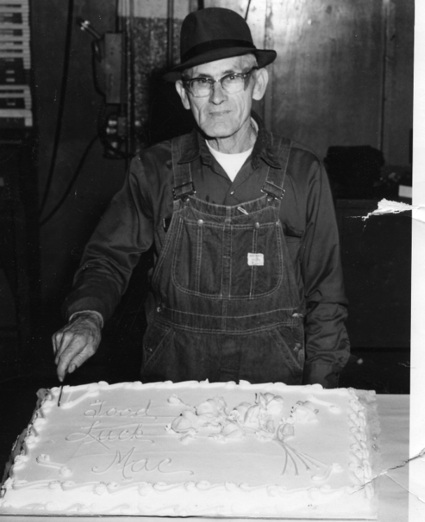
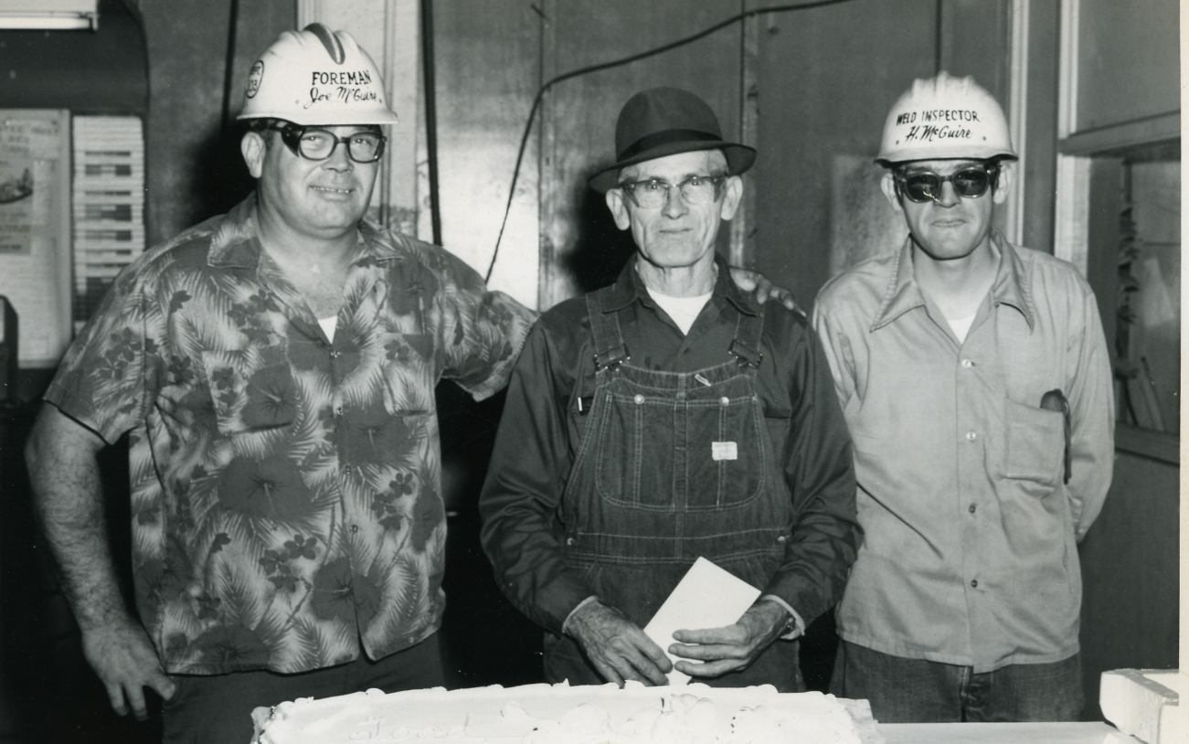
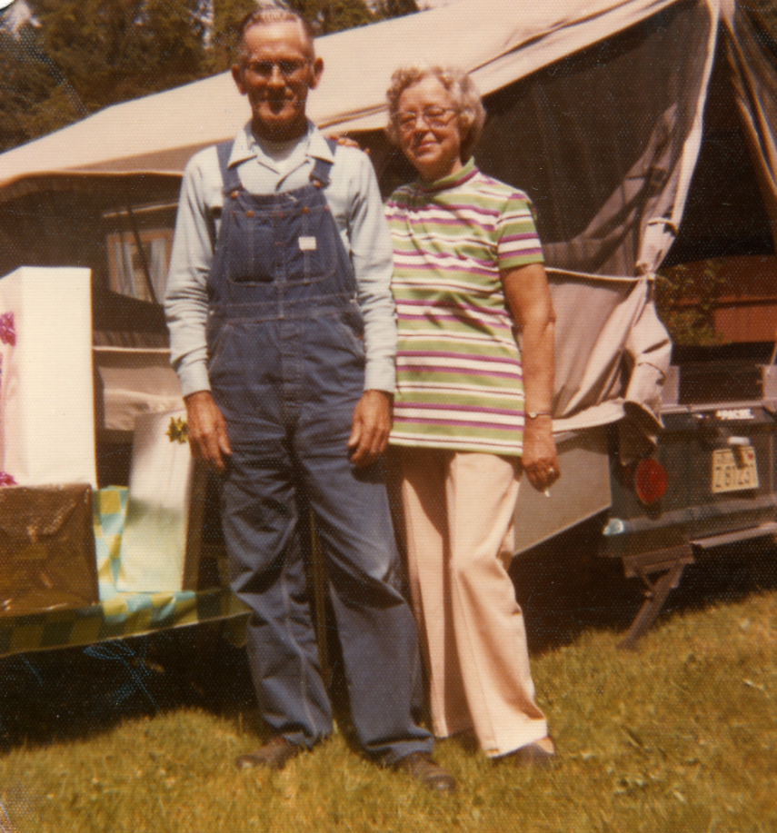
They owned a light blue car and went on vacation to see his family in Modesto California. Somehow they ended up taking a wrong turn and ended up in a parade. Grandma just waved. I can just imagine what that was like and I bet Grandpa chuckled.
I remember Grandpa and Grandma would come down most Saturdays when they would do their shopping. I never had the opportunity to spend the night at their house, but my older siblings did.
Grandpa always called my Mom “Sis” and Grandma called her “Sister” I think that is probably why Mom’s brothers always called her “Sis”.

On December 22, 1978, Grandpa and Grandma celebrated their 50th, and last, in this life, Wedding Anniversary at the home of Virginia and Terrell Rogers.
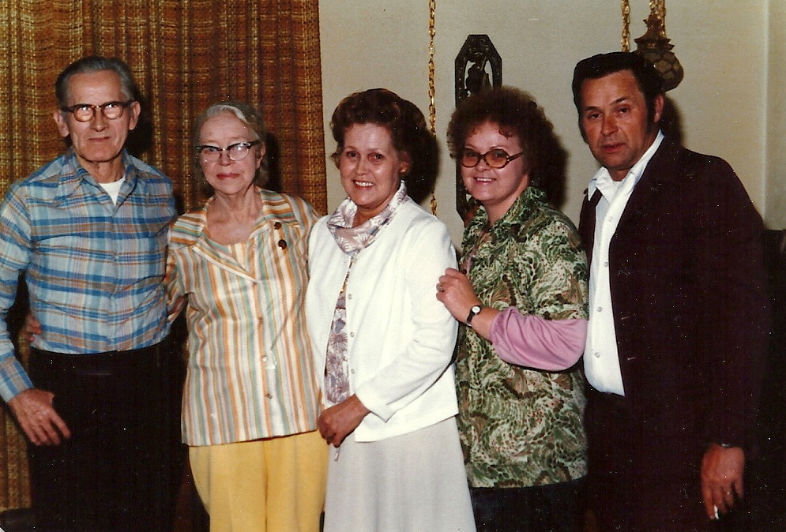
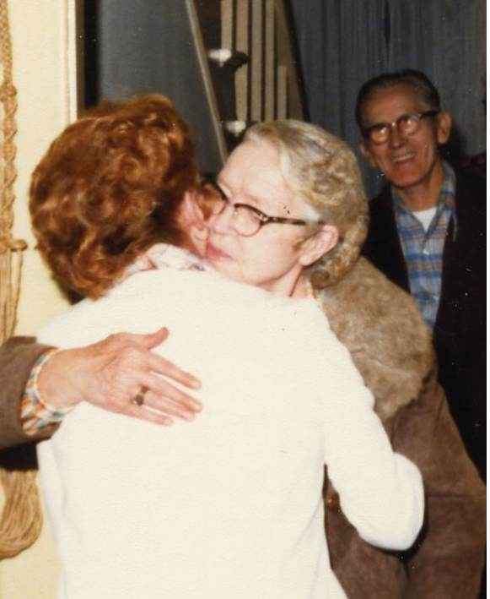

On June 14, 1979 Grandma Ada Morgan McGuire had a heart attack. I was at our Church practicing for a performance with my brothers, Les, Randy and Noel. Noel left because he had to get up early for work. Not long after he left, I had this horrible feeling that something was wrong. I assumed it was Noel. I called home and Sheri told me he was home and in bed. The feeling didn’t go away. Randy took me home that night and when we got to the door, Sheri opened it and said “Grandma’s had a heart attack”.
She lingered until Sunday, June 17, 1979 and went home. Grandpa and Grandma never attended Church, as far as I know, but she loved Billy Graham and I believe that she believed in our Heavenly Father and Elder Brother, Jesus. I remember thinking, she was 9 when her Father passed away, and she was 20 when her Mom passed away. I know in my heart that both Grandpa and Grandma have accepted the Gospel.
Grandpa McGuire and my Mom, Virginia Louise McGuire Rogers, at Hill Crest Burial Park, Kent, King, Washington, a few days after the funeral for Ada Morgan McGuire.
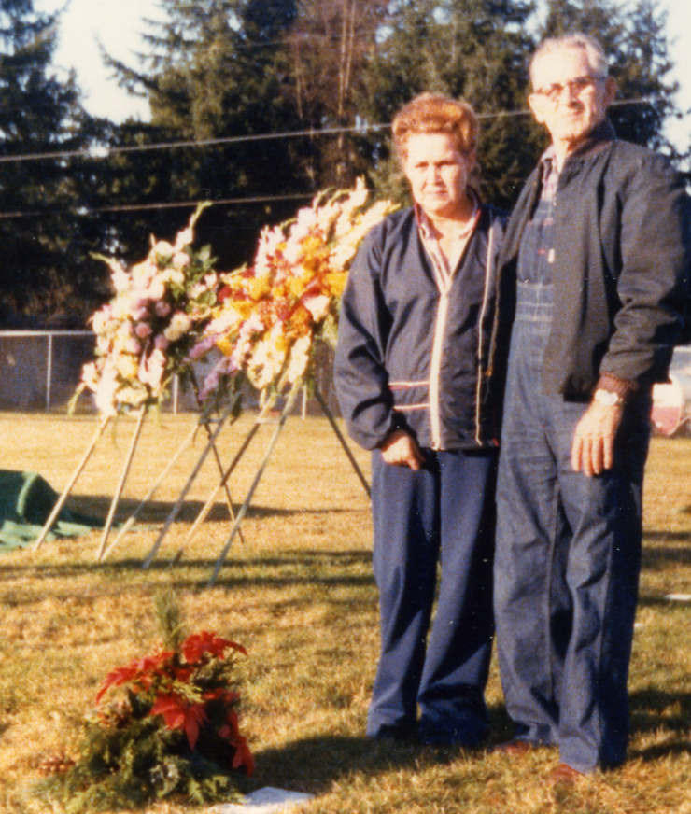
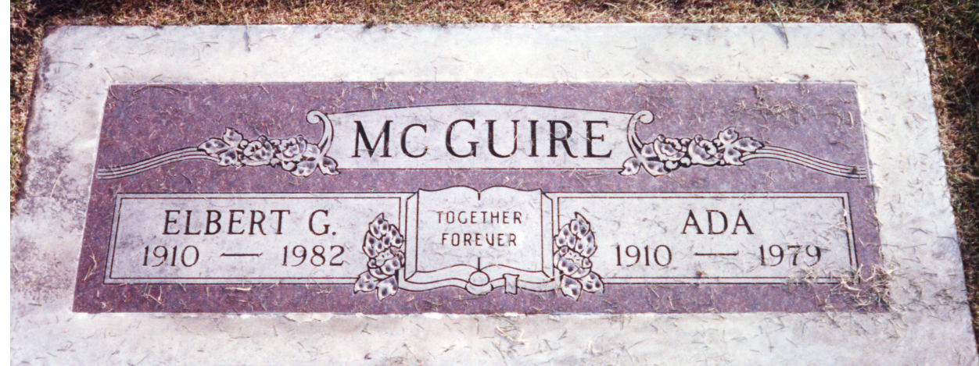

August of 1979, our Family went on Vacation to California to see our Grandpa Rogers. We took Grandpa McGuire with us. We visited his sister, Susie and his brother Eugene. This is the last picture of them together.
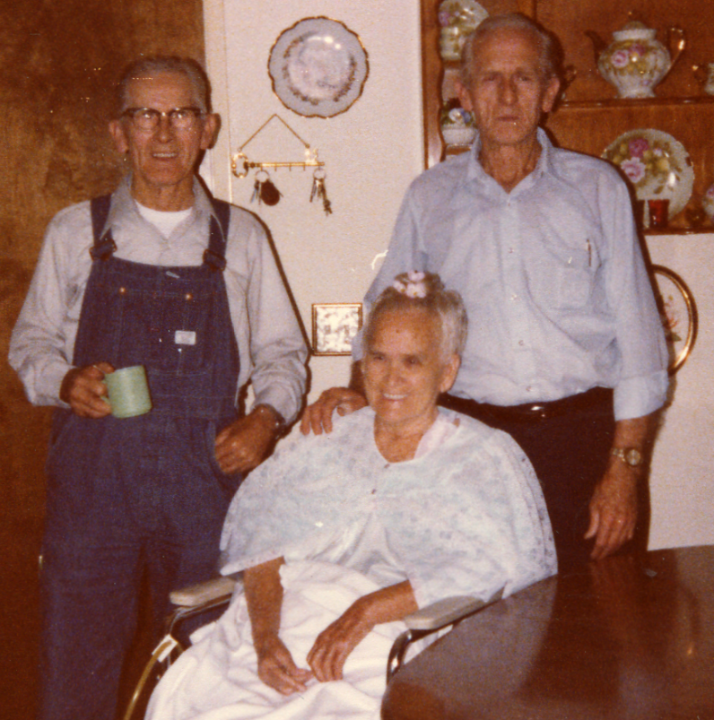
We then went to Reno Nevada and this picture is of Grandpa McGuire playing a slot machine in Virginia City Nevada.
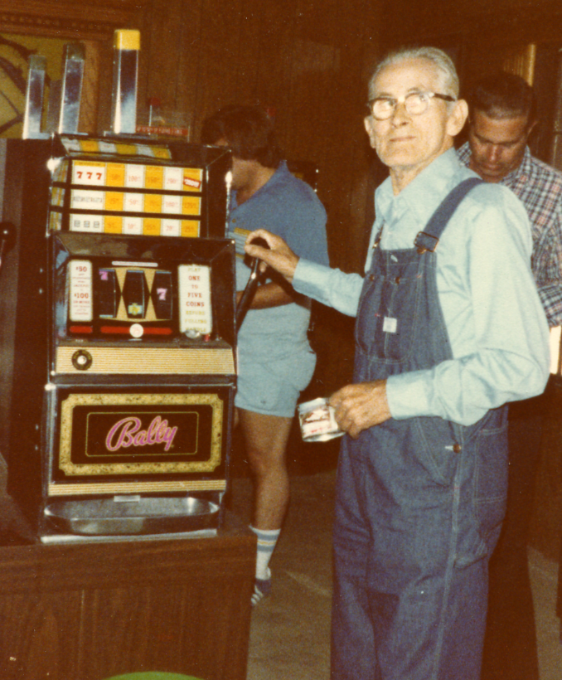
In August of 1980 Grandpa bought a new car, a Toyota Corolla and drove to Arkansas to see Family. It was a very hot summer and his car did not have air conditioning. But he made it. I can just see him driving 30-40 mph down the interstate.
1981. Grandpa started having trouble. It would be months before he would tell anyone that there was blood in his urine. He was diagnosed with Prostate Cancer. I remember he had surgery, I remember the Doctor appointments. I took him to 1. We were driving down 167 toward Renton. He said to me, just because the speed limit is 55 doesn’t mean you have to go 55. I said it kind of does Grandpa. He said aww
In the spring of 1982 Grandpa moved into our home. He was so frail. His appetite was gone, but Mom insisted he eat. She nearly killed herself trying to cook what he would want to eat. He loved Veal. I came home from work one night and Mom was beside herself because he wouldn’t eat. She sent me to the store to buy Veal. She prepared it, and he wouldn’t eat. She was so upset. I remember telling her that liquids were probably more important. .
Grandpa was in the smaller bedroom upstairs and I was just across the Hall. I woke up many nights to him crying and praying to the Lord for forgiveness. I heard enough to know that is what he was doing, but his voice was muffled and frail and the pain meds or exhaustion finally won and he was able to sleep.
He would come downstairs sometimes. He was always in a robe. It was so odd to see him in a robe and not his overalls. But when he was downstairs, it meant he wasn’t hurting as much.
By September, Grandpa was in the Hospital, never to come home again. I visited him a few times, but he was always sleeping, or medicated to the point of sleeping. He would wake up sometimes. He asked my Mom if he missed Jodi’s wedding. He bought my wedding cake. I would so have loved to have had Grandpa at my Wedding, but it wasn’t meant to be.
He died Tuesday, October 5, 1982 at Valley Medical Center, Renton, King County, Washington. He was 72 years old.
My memories of Grandpa are not the same as my older siblings, or older cousins. I didn’t know Grandpa in his younger days. I knew him as he was nearing retirement and after. I would love to know more about their younger years.
Somethings I have heard.
I know that times were hard.
I know that the McGuire and Morgan families traveled together from Arkansas to California. They had to stop along the way to work to earn enough money to continue on their journey.
Grandpa went to Sumpter Florida to run off Aunt Susie’s 2nd husband, John Pinkey Matthews because he was mean.
I know that Grandpa McGuire’s brother Charles dated Grandma McGuire first.
When my mom was a baby, Grandpa and Grandma were leaving to go to California, where my Uncle JD was born. Granny (Elizabeth Maud) didn’t want them to go and take my mom, so she took my Mom and wouldn’t give her back. Of course she finally did.
Grandpa and Grandma McGuire returned to Arkansas, where my Uncle Lucky was born.
But then by 1935 they were back in California, where Aunt Mina was born.
Then in 1955 they moved to Washington where they would live out the remainder of their life.
I know Grandpa always felt guilty for talking his Mother, Elizabeth Maud Howard McGuire, into having a mastectomy when she was diagnosed with Breast Cancer. He said she was in pain the rest of her life.
I know that Grandpa got along well with Grandma McGuire’s family.
I know they picked cotton for a living at one point. Grandpa worked for the W.P.A. in California, Pacific Car and Foundry in Washington.
They were in the field picking cotton when the Telegram came that Uncle First Morgan had been killed in action in WWII.
He called his daughter, Pam, Permelia.
His Granddaughter, Sherrell Glynn (Sheri) middle name was after him.
His Grandson, Glenn Harrison was named after him.

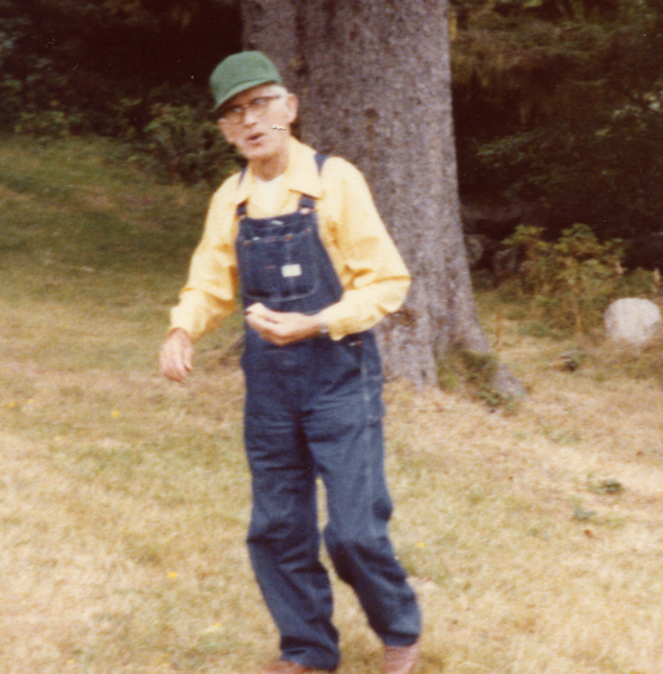

Grandpa loved his property. He loved trees. He didn’t like it when trees were cut down. Grandpa had an opportunity to purchase several acres of property for $1,700 but he mulled it around for a year. Then decided he wanted to purchase the property, he purchased 3 acres for $1,700.00. He built their final home in stages, first the Kitchen and Bedroom, then the Bathroom and living room.

Signature in 1940 on the WWII draft card
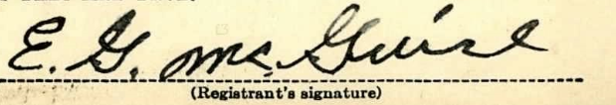

Joellen (Jodi) Rogers Johnson – Granddaughter of Elbert Glen McGuire.

